1. Display the records from emp table having employee names starts with letter ‘M’.

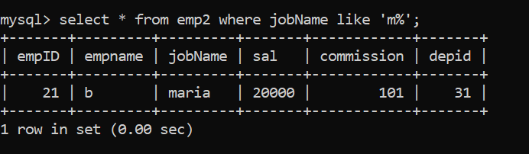

1. Display the records from emp table having employee names starts with

any letter but second letter ‘M’.

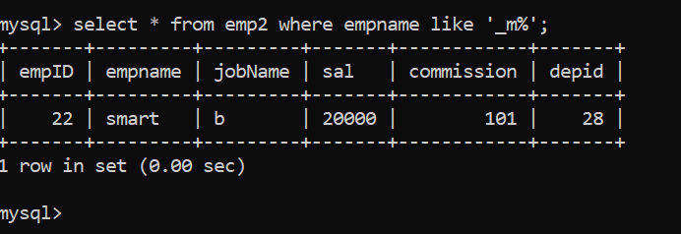

1. Display the records from emp table having employee names ends with letters ‘al’

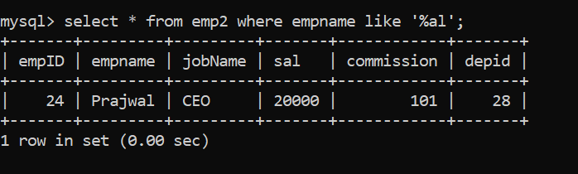

1. Display the records from department table for 3 departments

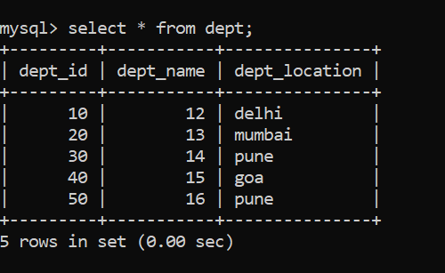

1. Display the records from department table by excluding 2 departments.

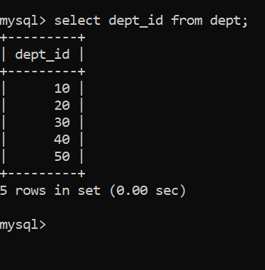

1. Insert 2 records in emp table with job column as NULL values.

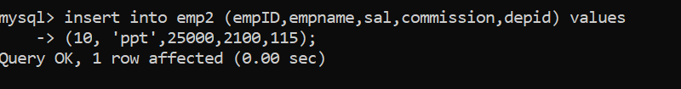

1. Display records from emp with job column is null

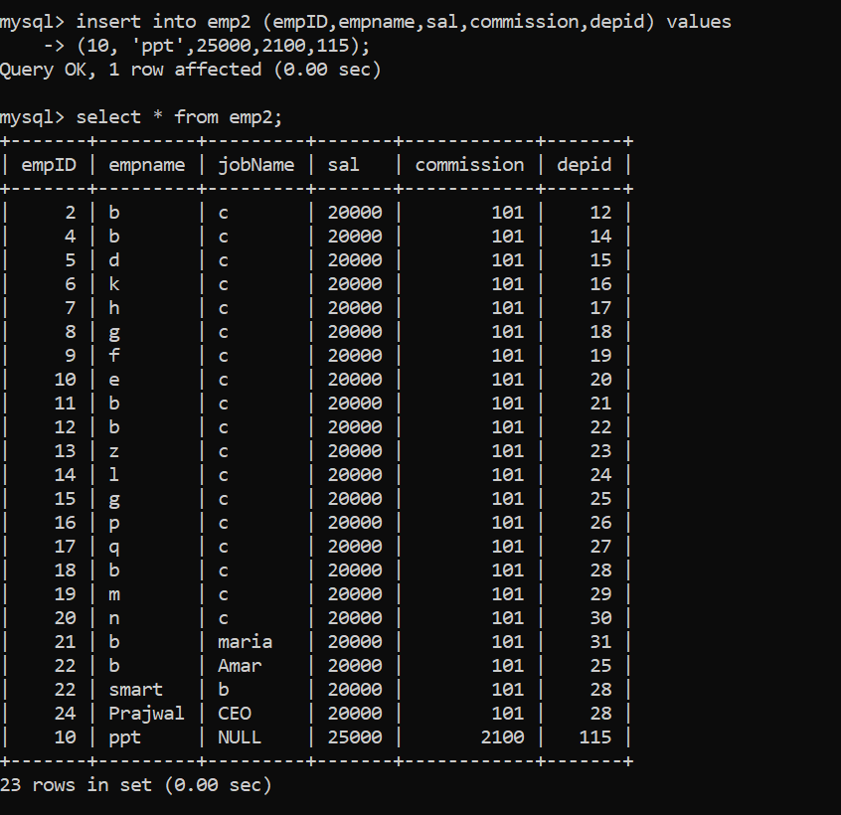

1. Display records from emp with job column is not null

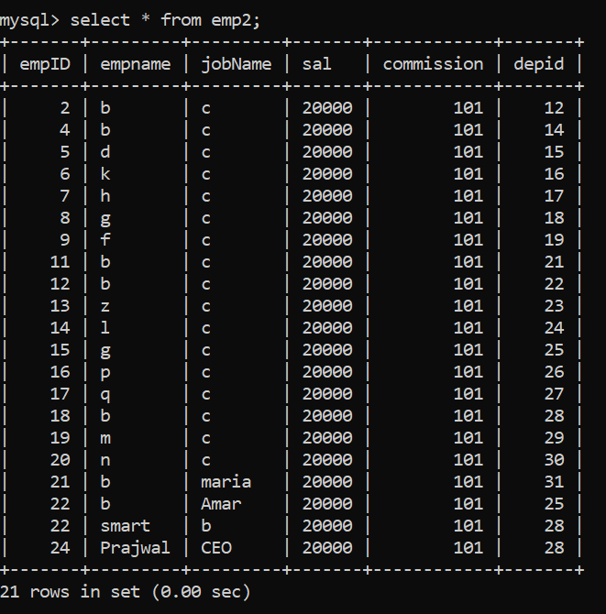

1. Display records from emp table with multiple conditions in Where clause such as departmentid={any value} and salary <4000

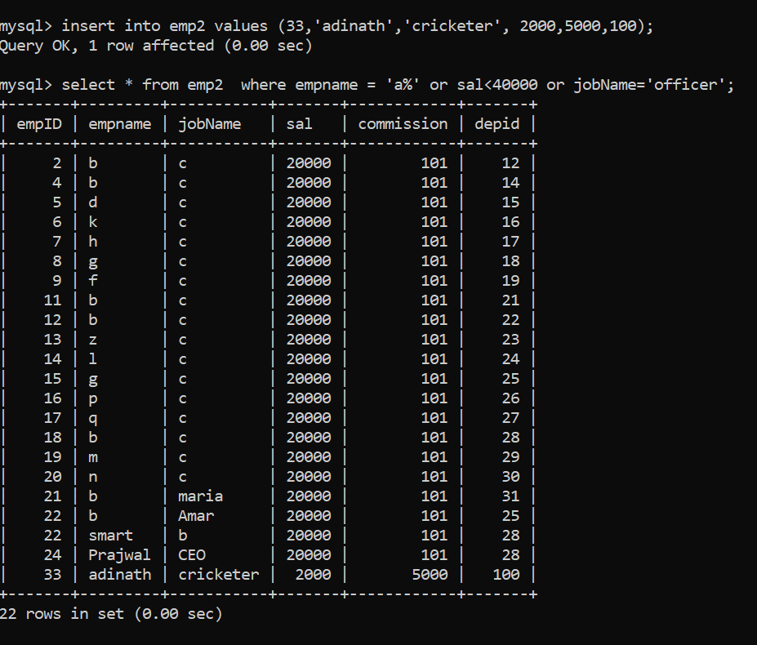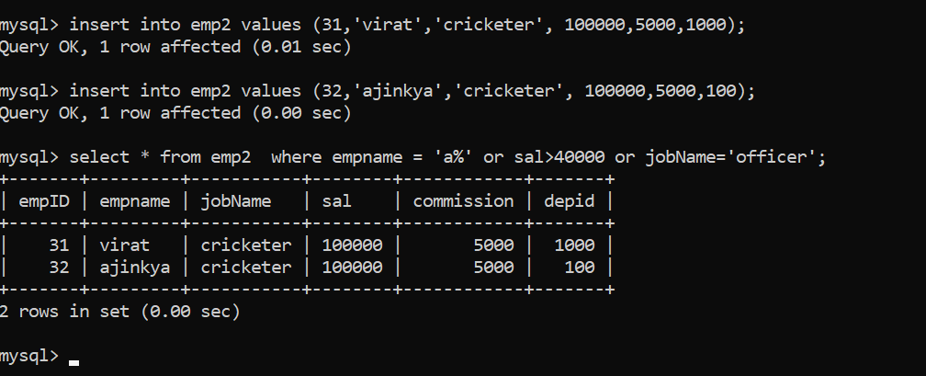

1. Display records from emp table with multiple conditions in Where clause such as emp name starts with letter á’ or salary > 40000 or jobname=’officer’

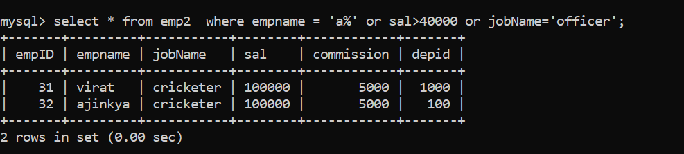

1. Create a table named customer having following column Custid int, custname varchar(100), address varchar(100)

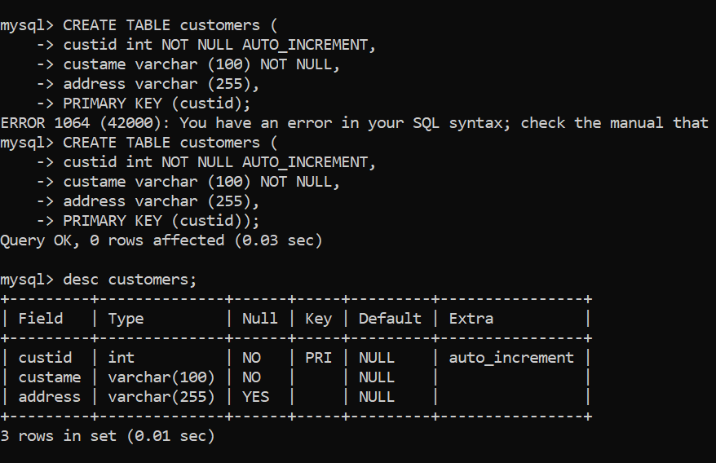

1. Set custid column as the autoincrement column and starts with 500

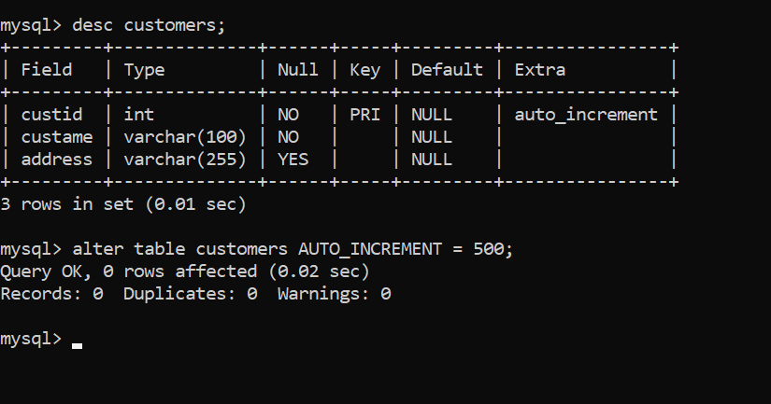

1. Insert 3 records in customer table

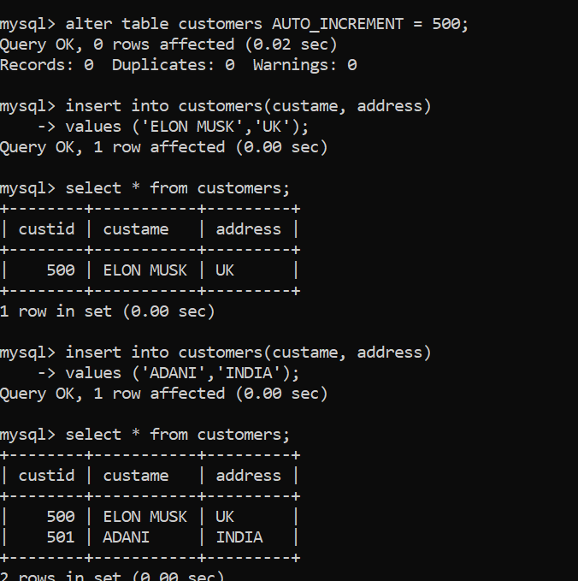

14. Create a copy of customer table named customer1 with only data from

customer table

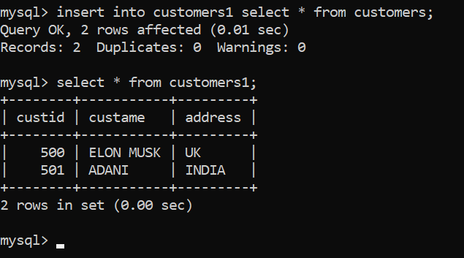

15. Create a copy of customer table named customer2 with structure and

data from customer table

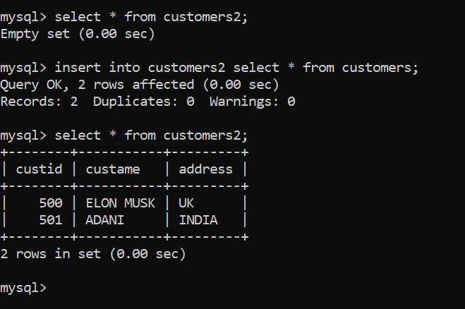

16. Display the Minimum and Average salary of employees in each department from employee table grouped by department id

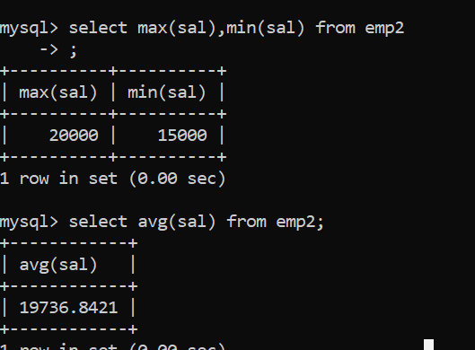

17. Display the maximum salary of employees in a department where that department has more than 5 employees

